Responsive Design: Photography website

🎯 Objective
Your task is to take a provided, unresponsive photography website (HTML + CSS + images) and make it responsive for mobile devices. The site currently uses a rigid desktop layout that will break on small screens. So the goal is to implement a single media query to fix this problem.

Your Task
Create a file named responsive.css and inside it, use a media query to override the fixed desktop properties from style.css to achieve the vertical, stacked mobile layout.
Output: your page shall look like the image below on small devise | Constraints (CRITICAL)
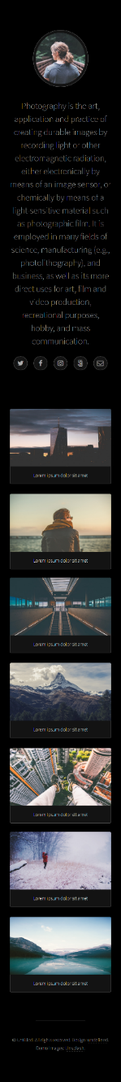 | You must adhere to the following rules:  - You are NOT allowed to change the provided HTML (index.html) or the original CSS (style.css). Your solution must work purely through CSS overriding and the cascade.  - Your output MUST be a single, separate CSS file named responsive.css.  - The media query must target max-width: 600px.  - Pixel-perfect implementation is not required, but the layout must correctly stack and fill the screen on mobile.
 | Starting Files
You have been provided with the following
- index.html
- style.css
- images

Submission:

A link to a publicly hosted version of your webpage (e.g., using GitHub Pages, Vercel, or Netlify).

